The Template spreadsheets are locked & password protected to prevent unauthorized changes and access to sections that are not data entry fields.

Any alterations to column labels & headers in rows 3, 4, 5, & 6 need to be reviewed carefully. The text string values are referenced and used in some of the migration schema Stored Procedures and any changes to the existing string values could impact the ability of the Import process to correctly import Training Event template files. This especially applies to the following sheets and cells:

Training Event Participants: B3, B4, B5, & AK6

Training Event Instructors: A3, A4, A5, & AJ6

1. Lookup Values sheet/tab is hidden to prevent accidental changes to the lookup values.
   * Process to hide the Lookup Values sheet/tab:
     1. Select the Lookup Values sheet/tab.
     2. Select the **Home** menu/ribbon option and then click **Format**.
     3. On the **Format** menu drop-down click on **Hide/Unhide** and then on **Hide Sheet**.
     4. The Lookup Values sheet/tab should now be hidden and not visible.
   * Process to unhide the Lookup Values sheet/tab:
     1. Select the Home menu/ribbon option and then click Format.
     2. On the Format menu drop-down click on Hide/Unhide and then on Unhide Sheet… .
     3. Select the Lookup Values sheet/tab in the list and then click OK. The Lookup Values sheet/tab should now be visible.
2. The individual spreadsheets are completely locked and non-editable, except for those cells that users are supposed to enter data into.
   * Password to protect/unprotect worksheets: gttstemplateversion3
   * Process to protect a worksheet:
3. Select all the cells that should be unprotected. Use CTRL-CLICK as needed.
4. RIGHT-CLICK & select Format Cells…
5. On the Protection tab, remove the checkmark from the Locked checkbox and click OK.
6. Select the Review menu/ribbon option and then click Protect Sheet.
7. Enter the password (gttstemplateversion3) and set the checkboxes as shown:

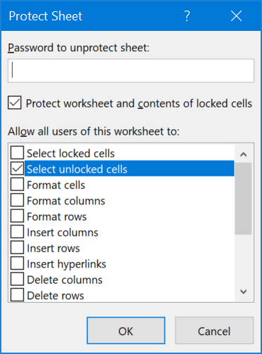

* Reference URL on how to protect/unprotect specific cells: <https://www.laptopmag.com/articles/lock-cells-excel>

1. Once all the individual sheets have been locked down, the entire workbook .xlsx file needs to be protected against structure changes.
   * Password to protect/unprotect the entire workbook (.xlsx file): gttstemplateversion3
   * Process to protect the workbook (.xlsx file):
     1. Select the **Review** menu/ribbon option and then click **Protect Workbook**.
     2. Enter the password (gttstemplateversion3) and set the checkboxes as shown:

